Joel Atkinson
March 24,2026
CSD440 Server-Side Scripting
Assignment 1.2

Link to CSD-440 GitHub Repo: https://github.com/Joelatkinson95/CSD-440

Screenshot of setting up and cloning GitHub Repo in my CSD Repo through my terminal:
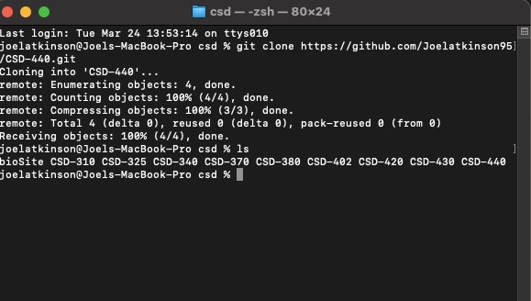

Screenshot of my GitHub Repo:
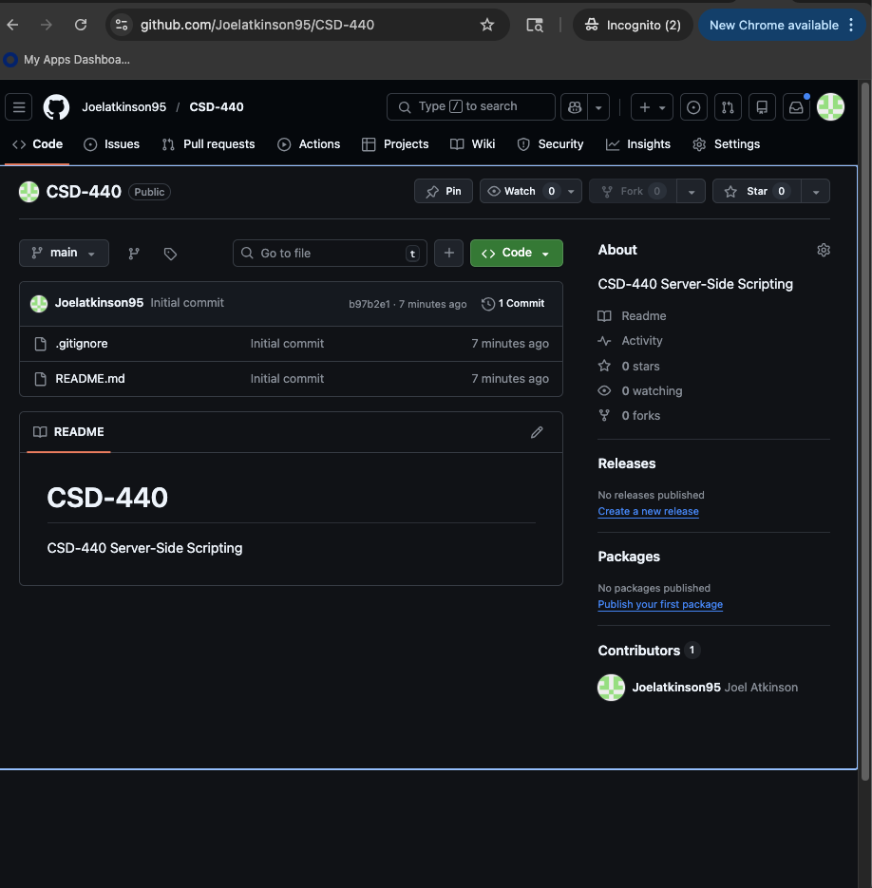
Screenshot of my computer directory with my new repository in CSD:
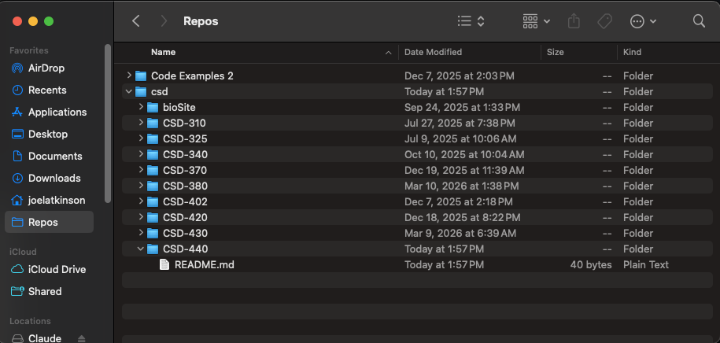

Screenshot of my new Repo opened as a project in my IntelliJ IDE:
